Are you WIRED?

Name: Age:

Where do you live:

1. Do you go to a youth club?

Once a week Once a month Never

2. Do you feel you have a say in what happens in your community?

Yes No Unsure

3. Do you think people listen to your opinions?

Always Sometimes Never

4. Do you think that young people living in rural areas miss out on things?

No Yes Sometimes

If yes, what sort of things do you feel they miss out on?

5. Would you like to learn new skills? Would you be interested in coming along to a project to work with other young people to have fun, get creative and make your voice heard?

Yes No

6. If you came along to project like this would you prefer to attend it for one week in the summer or one day a week over six weeks?

Over one week Over six weeks Don’t mind

PART 2

7. What do the words ‘Social Media’ mean to you?

8. Do you use the internet? If yes, how often?

Everyday Once a week Once a month

If not, why not?

If you don’t use the internet but would like to, what would you use it for?

9. Do you use any of the following?

Twitter

Everyday Sometimes Never

Facebook

Everyday Sometimes Never

Do you download music and movies or do you prefer to buy them on CD and DVD?

Download them Buy them on CD and DVD

Do you have a mobile phone?

Yes No

10. If you have a mobile phone, what do you use it for (apart from making calls!)

11. If you don’t have a mobile phone, would you like to have one?

12. If you have a mobile phone, or people you know do, is it sometimes hard to get a signal?

Often Never

If you wanted to send a message to all the young people in the world how would you do it and what would you say?!

Would you like us to email you about the project we are planning?

Yes please! Not this time, thanks

If yes, please leave your email address:

Email:

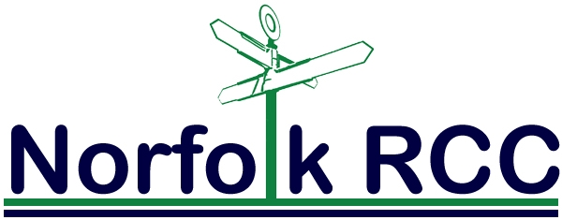

Thank you for taking part in our survey!

